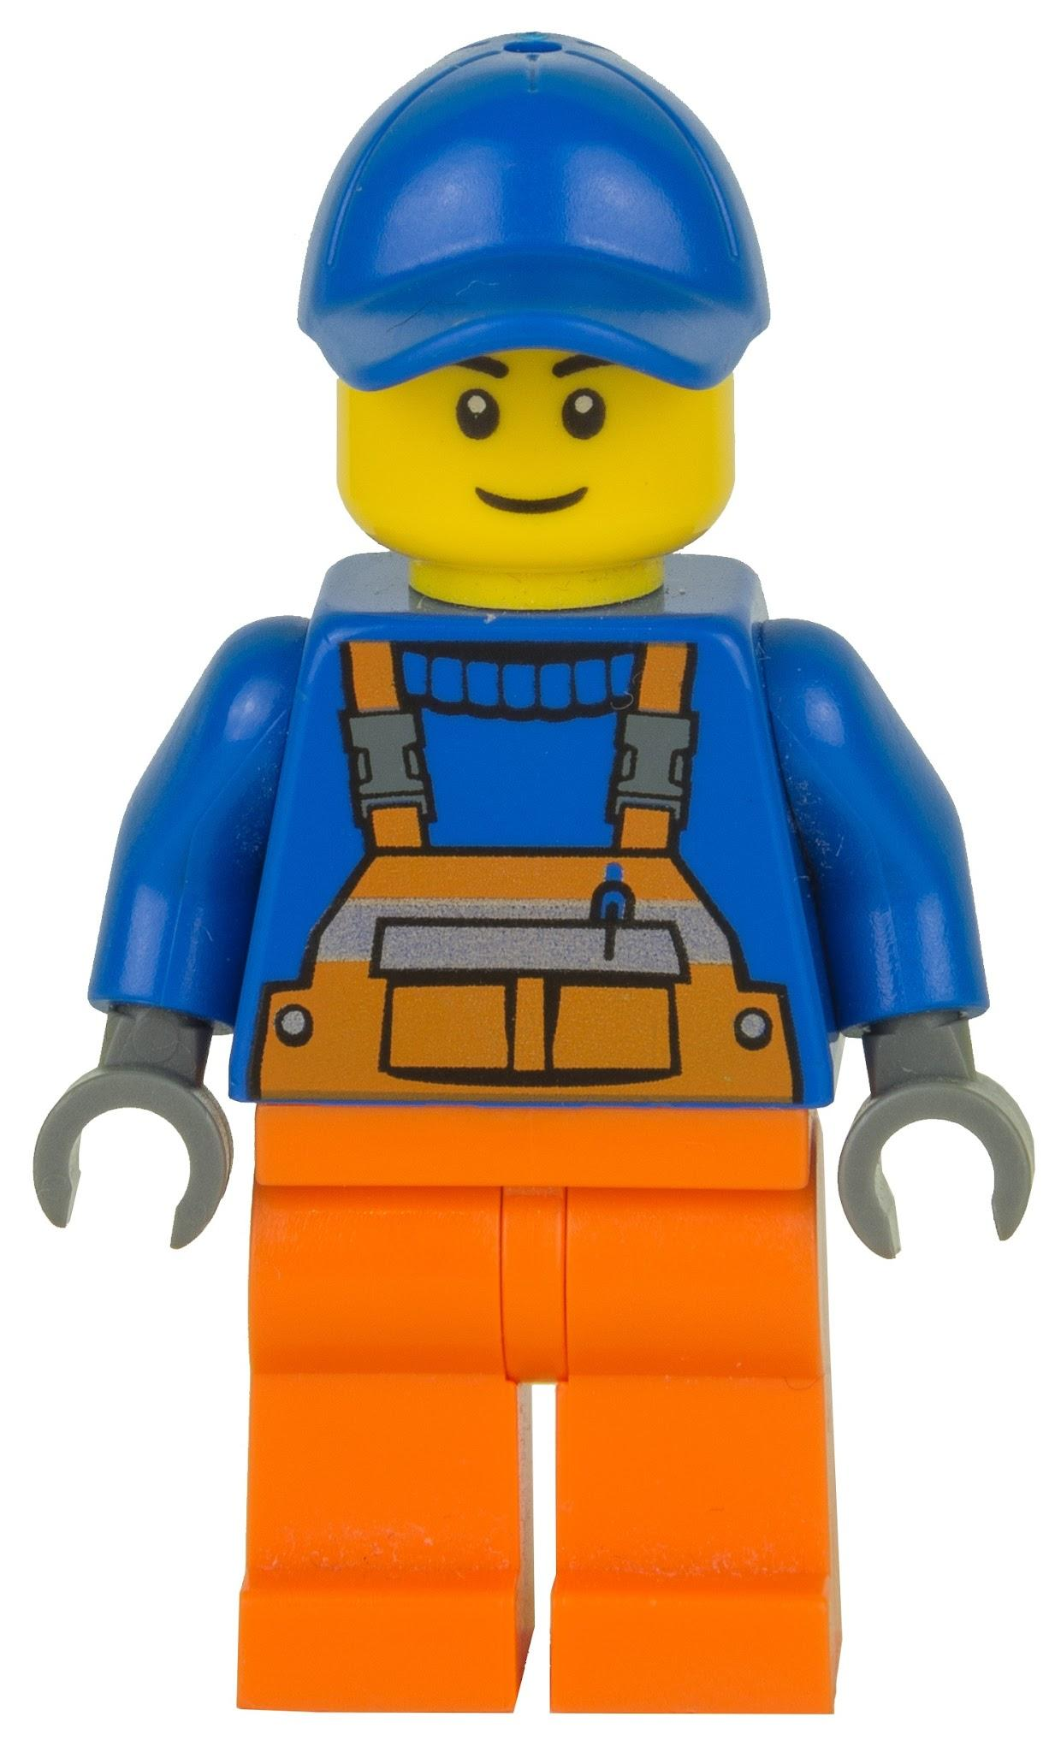

**“EVERYTHING IS AWESOME”**

**LEGO BUILDING CONTEST**

**Official Rules:**

1. All creations must use your own LEGO, DUPLO or MEGABLOCKS bricks.

2. No other materials (glue, paper, etc.) are permitted in the creation of your entry.

3. If your creation has multiple pieces, you must provide cardboard or other solid surface to display your creation on.

4. All entries must be completely original creations. No designs from LEGO, websites, books, kits, etc…

5. Team entries are permitted.

6. Completed projects must be delivered to the children’s library during open hours Monday, March 3 thru Friday, March 7.

7. All LEGO creations will be on display in the library March 10 thru March 14.

8. Prizes need to be picked up on and will be awarded on Monday, March 17.